Monometer

📏 What is Monometer
# Source: Chatgpt (GPT-4-turbo) at [8/2/2025]
Term | Definition
Monometer | A poetic meter consisting of 1 metrical foot per line.

🧱 Structure:
# Source: Chatgpt (GPT-4-turbo) at [8/2/2025]
- “Mono-” = one
- 1 foot per line → Very short lines
- The type of foot (iamb, trochee, etc.) determines the rhythm.

📝 Example:
# Source: Chatgpt (GPT-4-turbo) at [8/2/2025]
From Robert Herrick’s poem “Upon His Departure Hence”:
Thus I
Pass by
And die:
As one,
Unknown
And gone.
Each line contains only one metrical foot, making it monometer.

🎭 Effect:
# Source: Chatgpt (GPT-4-turbo) at [8/2/2025]
- Creates punchy, dramatic, or staccato rhythm.
- Often used for emphasis, brevity, or emotional isolation.

🔄 Variants:
# Source: Chatgpt (GPT-4-turbo) at [8/2/2025]
You can have iambic monometer, trochaic monometer, etc., depending on the type of foot used.
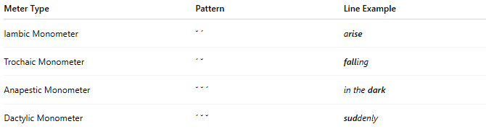
Meter Type | Pattern | Line Example
Iambic Monometer | ˘ ´ | arise
Trochaic Monometer | ´ ˘ | falling
Anapestic Monometer | ˘ ˘ ´ | in the dark
Dactylic Monometer | ´ ˘ ˘ | suddenly

📚 Where It's Found
# Source: Chatgpt (GPT-4-turbo) at [8/2/2025]
Monometer is rare and typically used for stylistic or dramatic effect. It appears in:
- Experimental poetry for creating tension or surprise
- Refrains or choruses in lyrical or songlike poetry
- Minimalist verse to emphasize a single word or idea
- Occasional use in modernist or concrete poetry
- Poems with staggered line lengths for visual rhythm
Because of its brevity (only one metrical foot per line), monometer is most often combined with longer lines in mixed-meter poems.

